The Mundens with Sacombe
Church and Parish
Newsletter
JULY 2025

CHURCH SERVICES
Every Tuesday
9.30am Holy Communion (BCP)
and Bible Study Sacombe
Every Wednesday
9.30am Worship & Bible Study Standon
Sunday 6th July (Trinity 3)
8.00am Holy Communion Standon
10.30am Morning Worship Lt Munden
Sunday 13th July (Trinity 4)
10.30am Holy Communion Standon
Sunday 20th July (Trinity 5)
8.00am Holy Communion Standon
10.30am Holy Communion Lt Munden
Sunday 27th July (Trinity 6)
10.30am Morning Worship Standon
6.00pm Choral Evensong Standon
Sunday 3rd August (Trinity 7)
8.00am Holy Communion Standon
10.30am Morning Worship Lt Munden
Rector: Revd John Chitham 01920 739483
The Vicarage, Standon
Sacombe Churchwardens:
Janet Armstrong 07376 249047
Derek Wheeler 01920 438875

Website: www.achurchnearyou.com/benefice/32-240BF
www.facebook.com/unitedbenefice3

LETTER FROM THE RECTOR
Dear Friends
Following the open gardens, I was struck by some words of Job in the Bible:
“Ask the animals, and they will teach you,
or the birds of the sky, and they will tell you,
or speak to the earth, and it will teach you,
or let the fish of the sea inform you;
by God’s hand is the life of every creature.
To God belong wisdom and power;
counsel and understanding are his.” (Job 12:7f)

Of course, the animals do not speak (at least in words; this is not Dr Doolittle!). The point is different. As I look at all of creation, I can see the hand of God. I can learn wisdom from the Muntjac disappearing into the hedgerow at danger, or understand how the soil produces flowers if given a chance to recover. I see the fierce protection of the crows against the Red Kite as it comes to their nests. I see the trout leap for food that hovers just above it. And that was just this week!

The technical term for this is natural theology. It means quite simply that, if we look, we can see the hand of God just in the natural world. Not all is perfect (it is not as he intended) but there is enough to make us wonder and question: surely there must be more to life than just the material. A sunset shining salmon pink; a thunderstorm dark and foreboding; the blazing sun beyond my capacity to think; an exquisite rose, just perfect. We are fortunate enough to live in a part of the world where God is seen easily, despite humans’ best attempts to ruin it.

It does, however, require a response. The first should be simple gratitude. One of the things that I love about being a Christian is that I have someone to thank. I can thank God. But, in any case, we should all be grateful. A second response needs to be protection. How do we stop all the attempts to ruin what God has given? Global warming, pollution, misguided regulations, poor water companies; the list is pretty long. We have a role to play. But the third response is to seek out the God who gives all of this. He longs to be known; he loves us and already knows us. He can be found if we are willing to seek. Perhaps the most important prayer anyone can pray is, “God, reveal yourself to me”. If we do that, he will answer.
John Chitham

COUNTRY MATTERS (10th July)
The amount of rain we’ve had in this area so far is not nearly enough. Time is getting on, forcing us to start mowing, although it’s a very light crop. Gardens need rain desperately, especially lawns. It’s nearly time to pick gooseberries, which are only the size of peas.
The first pen of lambs has gone for slaughter, which is quite early. We’re waiting for more warm sunshine before shearing starts. The little bit of rain we’ve had so far has given the grazing fields a small boost, much to the satisfaction of the cattle.
It’s good to see quite a few young birds about. I’m using up some old peanuts in the feeders, and a whole family of Great Spotted Woodpeckers are taking advantage of it. It’s sad news to hear about the disease affecting Blackbirds, spread by mosquitos, although so far we seem to have the usual population around the farm. I suppose this kind of thing is to be expected as the planet warms up.
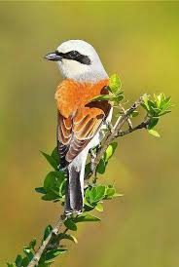
BIRD OF THE MONTH – Black-backed Shrike
This bird unfortunately no longer breeds in this country, but an odd one may be seen on migration. In my youth I knew of several pairs in my district. It’s not quite as big as a Thrush and, as it’s name implies, has a reddish-brown back. They used to be found wherever there were thorn bushes such as blackthorn, briars and brambles. They have a habit of impaling some of their prey which consists of small mammals, small birds, lizards and large insects, on thorn bushes as a larder, hence their other name of Butcher Bird.
Tony Spackman

MONTHLY COFFEE MORNING
Coffee and cake or
Russells famous sausage rolls for £6!
at the
Christmas Tree Farm from 9 - 12 noon
On Friday JULY 18th…..
AND
The Monthly PIZZA and Wine/Beer etc.
On Friday JULY 18th
From 7pm
Eat and drink all day!

THE BOOT BIKERS SUMMER BASH
SUNDAY 6th JULY
11am – 7pm
HORSES MEADOW, DANE END

Dane End Memorial Hall Is Taking Bookings
Landline: 01920 438875
Email: dg_wheeler@hotmail.com
Available for hire by the hour or mornings, afternoons and evenings
If you want to arrange a birthday party, start a bridge or table tennis club.....
Give us a call!

DANE END DEFIBRILLATOR & VETS NUMBER
Please be aware there is a Public Access Defibrillator situated in the telephone box in a locked cabinet next to Dane End Stores. The code for the cabinet can be obtained by ringing 999. However there is also Village Emergency Telephone System (VETS) that enables up to 10 "good neighbours" to assist pending the arrival of the emergency services. VETS uses a simple memorable number unique to the village (01920 282999). This system can also be used for any emergency where additional help is required from neighbours, whether Cardiac Arrest or not. VETS volunteers are also aware of the code to access the cabinet if it is required. VETS does not replace 999 calls. Always ring 999 first in an emergency.

LITTLE MUNDEN PARISH COUNCIL
A PARISH COUNCIL MEETING
Will be held on
TUESDAY 18th JULY
in LITTLE MUNDEN VILLAGE HALL
AT 7 PM
Clerk@littlemundenplc.org.uk
ALL ARE WELCOME TO ATTEND
THERE WILL BE NO MEETING IN AUGUST
Little Munden C of E (VC) Primary School

Building Good Foundations. Matthew 7,
verse 24
Church Lane, Dane End, SG12 0NR.
Tel: 01920 438271 option 3
Email: admin@littlemunden.herts.sch.uk
www.littlemunden.herts.sch.uk

June 2025 We’ve had a very busy month!

During our Fitness Week, the whole school took part in our yearly Munden Mile race, hoping to improve our times from last year. Wednesday was our whole school sports day, with a round Robin of activities followed by the traditional races. Well done St George's team for winning this year.

KS 2 had a scooter workshop, with a world-record-holder leading the sessions! They learnt tricks, played games, and generally had lots of fun! They also went to Waterbeach Army Barracks near Cambridge to do an assault course. It was so much fun - although also very muddy, and pretty hard work! I think some clothes didn't even make it to the washing machine and went straight in the bin when the children got home!



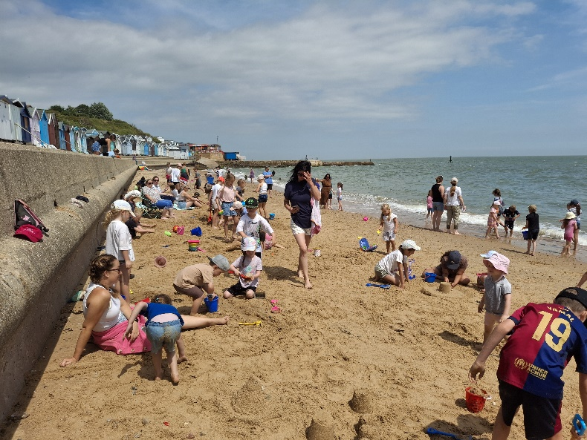
We ended the month with a whole school trip to the beach - lots of sandcastles, channels, digging and burying the legs of children and members of staff. Some of the children built a mini-spa area and there was lots of paddling in the sea and jumping over waves. The day was finished off with a cooling ice lolly. What a busy month we’ve had, but what a lot of fun had by all!



LITTLE MUNDEN PARISH COUNCIL
Dear Parishioners
I hope you are all enjoying this lovely weather, lets hope it lasts through the upcoming school summer holidays. Keep your eyes peeled for our Children's Cinema afternoon. This will be held in on Saturday 19th July venue and more details to follow soon so keep your eyes peeled on Love Dane End and the Little Munden School updates.
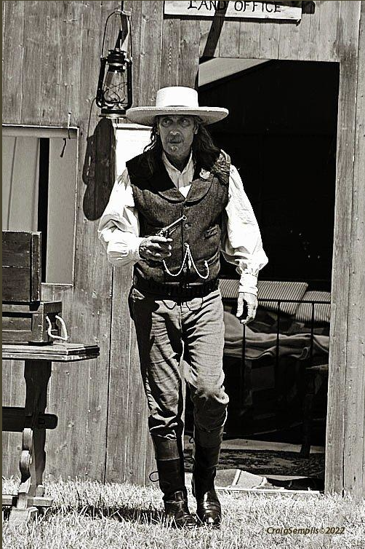
It won't be long till our village fete is upon us Saturday 6th September. We were originally going to have a village themed games but we didn't receive much interest so l sat and pondered and after a long cool drink it came to me like a bolt of lightening well spark. We have had the Vikings so why not have the Spearfish Creek re-enactment group. Who are they you may ask...two words 'Wild West' gives a great clue, the American settlers (Cowboys) are coming to Dane End and will be setting up camp for the weekend.
On the day of the fete you will be able to walk around the camp and speak to the settlers. There will be a gun fight so be warned there will be some loud bangs. There will be a children's adults fancy dress competitions (western themed clothing). We will still have our usual tug of war, dog show and stalls to look around, with a BBQ during the day and food trucks in the evening, a bar and much more. FOLM will be having some stalls to help raise money for Little Munden School. To round the day off we will be having a line dancing session so dust off your cowboy boots and get ready for a fun filled day. Why not invite your extended family to come and join the fun.
On another note, the Pantomime for this year will be 'Snow White not as you know it', auditions will be held on Tuesday 15th July at 5pm in the Memorial Hall, please come along if you are interested in getting involved either in the acting or behind the scenes we need as much help as possible. This is always great fun for all involved bringing a little bit of fun on a cold winters night. Please get in touch with Gerry The Clerk (clerk@littlemundenpc.org.uk), if you are interested or just come along on the audition day.
I would like to thank those parishioners who have adopted a street to keep litter free and also for cutting the grass on the corner of Church Lane this is greatly appreciated.
Best Wishes, Tracey - Chair LMPC

GREAT MUNDEN RECREATIONAL GARDEN

Community Picnic – 3rd August from 1pm
We look forward to seeing as many of you on the day. Please pop along with your packed lunch and your loved ones, we have many interesting activities organised. Owls Rescue talk, Hedgehog Rescue talk, Beekeeping talk, Jackie's ‘Alternative Antiques Roadshow’- bring your valuable items to learn about the history and be put in touch with valuers where necessary, Pétanque, garden games and an ice cream van!
Other activities at the Garden
Bird feeder weaving workshop with Judi
Saturday 6th September - 1pm to 5pm
£30 per person, maximum 8 participants
Please book early to avoid disappointment
Fee includes tuition, tools, materials and refreshments

Fruit basket weaving workshop with Judi
Saturday 13th September - 11am to 5pm
£38 per person, maximum 8 participants.
Please book early to avoid disappointment.
Fee includes tuition, tools, materials and refreshments.
Outdoor Chess with Tim – Juniors and Adults
Please come along from 6pm on Thursdays and enjoy a game against other local chess enthusiasts, while watching the sunset and listening to the peaceful sound of birds chirping and leaves rustling in the breeze. Tim is a seasoned chess player who volunteers throughout the winter at the Bishops Stortford Juniors Chess Club and has kindly offered to run an outdoors club at the Garden. £1 per person per session, to raise funds for the Garden. One parent will need to stay for the duration.
Yoga with Josie
Josie will be waiting for you in the Garden on Saturday mornings at 10am to catch the early sun 😊 Classes at the Garden cost £7 based on a booking of 4 sessions or £8.50 PAYG
Le French Club – Sundays 12pm
If you want to brush up on your French before your next holiday, join the French club and meet French speakers locally, learn new vocabulary and improve on your grammar. £1.50 per person, or £1 for concessions. Now back at the Garden unless the weather worsens.
Polyphonic – Jamming Session Sunday 29th June
Bi-Monthly Come along with your guitar, ukulele, drums, bongos, flute, violin, put on your best singing voice, clap or sing along to and join in the fun!!
Be Aware! Scam companies are contacting people re energy saving ‘offers’.
They are called the Renewable Energy Consumer Code. 08001930655.
They apparently get their information from Trading Standards.
All the companies are based in Essex.
They are: Blue On, EMS, Hybrid Homes,
Tres Energy, Think Green Partners and
Alternative Eco Solutions.

If contacted by any of these companies, the advice is to say ‘no thank you’ and hang up. They advise that it would be a bad idea to do business with them.

LOCAL CONSTABULARY Buntingford Rural West includes: Dane End, Green End, Haultwick, Little Munden, Great Munden, Levens Green, Nasty and are covered by: The local PC is PC 1853 Paul Chapman and the local PCSO is 6672 Karen Broad and PCSO 6633 Neil Major
Contact: 01992 533329 - non emergency or 101
Emergency always call 999
DEAF, HARD OF HEARING? Please text 07786 207 091 including who is needed: Police, Fire or Ambulance, where they are needed and what the problem is.

