The Mundens with Sacombe
Church and Parish
Newsletter
JUNE 2025

Every Tuesday
9.30am Holy Communion (BCP)
and Bible Study Sacombe
Every Wednesday
9.30am Worship & Bible Study Standon
Sunday 8th June (Pentecost)
10.30am Holy Communion Standon
Sunday 15th June (Trinity Sunday)
8.00am Holy Communion Standon
10.30am Holy Communion Lt Munden
Sunday 22nd June (Trinity 1)
10.30am Morning Worship Standon
6.00pm Choral Evensong Standon
Sunday 29th June (Trinity 2)
10.30am Morning Worship Sacombe
Sunday 6th July (Trinity 3)
8.00am Holy Communion Standon
10.30am Morning Worship Lt Munden
Rector: Revd John Chitham 01920 739483
The Vicarage, Standon
Sacombe Churchwardens:
Janet Armstrong 07376 249047
Derek Wheeler 01920 438875

Website: www.achurchnearyou.com/benefice/32-240BF
www.facebook.com/unitedbenefice3
LETTER FROM THE RECTOR
Dear Friends
Mundens Open Gardens are almost upon us! Saturday 28 June is the day. Please put it in your diary!
I want to advertise shamelessly in my article this time because so much work has gone into planning, and we think this should be a great day out for everyone in Dane End and the villages around the Mundens. It is only £5 and children (up to 18) are free.
What is there to see? Some lovely gardens, food and alpacas! Yes, one “garden” is actually the opportunity to see Derek Wheeler’s alpacas, Felix and Oscar, in Haultwick. For a little more money there will be lunch available at Stag Hall Farm in Great Munden, and food throughout the day at All Saints’ Church. There will also be a plant sale at the church and at some of the gardens. The gardens vary from the large, the ecological

to gardens we can reproduce in our own homes. Another “garden” is the church, with an exhibition of all the flowers and plants in the conservation area and tours of the church for those who have not seen the inside with an historic eye.
Tickets are on sale now on the internet and at the village shop. On the day you can exchange your virtual ticket for a wristband and the map at the church or at Stag Hall. Both will be available at the church and at the shop. The morning gardens open at 10.30, the afternoon gardens at 12.30, with some overlap; the church is open all day.
So please come and support. All funds raised will go towards the church roof which faces an alarming bill (we hope to start stage one of the work later in the year). You’ll need a car to get around, but all the gardens are within a 10 minute radius and you’ll see houses you never knew existed!
Let me finish with the famous Gurney poem (actually used at Bridget Wentworth-Stanley’s funeral, whose garden will be open). We can find God in many places, including the garden of Eden, the garden of Gethsemane and our own garden; also in church, of course!:
The Lord God planted a garden
In the first white days of the world,
And He set there an angel warden
In a garment of light enfurled.
So near to the peace of Heaven,
That the hawk might nest with the wren,
For there in the cool of the even
God walked with the first of men.
And I dream that these garden-closes
With their shade and their sun-flecked sod
And their lilies and bowers of roses,
Were laid by the hand of God.
The kiss of the sun for pardon,
The song of the birds for mirth,--
One is nearer God's heart in a garden
Than anywhere else on earth.
For He broke it for us in a garden
Under the olive-trees
Where the angel of strength was the warden
And the soul of the world found ease.
John Chitham
COUNTRY MATTERS (11th May)
So far our prayers haven’t been answered for rain, even on the forecast. Influenced by variations in the soil, the grass in large parts of the fields looks parched already. First time round the cows will have enough, but second time round is in the balance. There’s been more fly-strike in the sheep than usual, despite the dry weather; it’s usually more frequent when the sheep’s fleece is wet.
We’re hearing Chiffchaffs and Blackcaps singing every day, and one Lesser Whitethroat as well. I’m especially pleased to hear this as we had none at all last year. Plenty of Orange Tip butterflies around as usual and a few Speckled Woods.
I have never seen so many Dandelions as now, which is good news for the cows, although the lack of rain has left them very short.
One of our readers wanted to know what was causing the noise they heard at night in the vicinity of Ducketts Wood, Thundridge. Without hearing it myself, I can’t be sure, but I would guess it was a Tawny owl; it hoots, whereas Barn Owls screech and Little Owls mostly yelp.
BIRD OF THE MONTH Common Partridge
In England our Grey Partridge doesn’t live up to its first name and is outnumbered by the French or Red-Legged Partridge. I think it is possible that the cause for this is the amount of spraying used today. This means that there are no weeds in the grain crops or resulting stubble which harbour the insects that the chicks feed on at hatching.
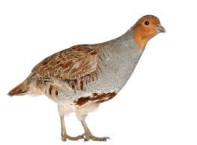
Our Partridge is very sociable, the family staying together until the following spring.
The whole family roost together in a field. They squat shoulder to shoulder in a circle facing outwards, so you may come across a little circle of droppings where they have slept.
Tony Spackman

DAME ENDERS
Thursday 5th June 4 pm
on ‘Horses Meadow’
We will be having a picnic!
This will start at 4 pm.
If you would like to come you will need to bring a chair or blanket, something to eat and drink and maybe also a sharing plate to pass around.
Should the weather be particularly bad on the day, the date may have to be changed.

On Saturday 7th June the bereavement group will be meeting again in Little Munden church from 2pm – 4pm. This group is for anyone who has lost their partner either recently or many years ago.
This is a very informal meeting to share a cup of tea and cake and to share our experiences.
If you would like to join us you will receive a warm welcome. If you would like to just turn up on the day that is fine or phone me on 07909065550 Heather Jackson.

LITTLE MUNDEN PARISH COUNCIL
A PARISH COUNCIL MEETING
Will be held on
TUESDAY 17th JUNE
in LITTLE MUNDEN VILLAGE HALL
AT 7 PM
Clerk@littlemundenplc.org.uk
ALL ARE WELCOME TO ATTEND

Little Munden C of E (VC) Primary School

Building Good Foundations.
Matthew 7, verse 24
Church Lane, Dane End, SG12 0NR
Tel: 01920 438271 option 3
Email: admin@littlemunden.herts.sch.uk
www.littlemunden.herts.sch.uk

May 2025
In Acorn Class, as part of our topic, ‘People who help us’, we were very lucky that one of our Acorn parents who is a paramedic came in with her colleagues and the ambulance. The children had the opportunity to ask questions about what it’s like to be a paramedic, as well as having the chance to be a patient. They even got the chance to sit in the driver’s seat of the ambulance too.






Beech class had a fun outing to Sele School to participate in a sports event. They practiced their throwing & catching, experienced orienteering, tennis and learnt some basic football skills! They all did really well and learnt lots of new things.

Little Munden School Choir had an amazing day at St Edmund's School. We spent time in their music department with the head of music, Mr O'Brien. First we had a go at drumming and percussions, both with African djembe drums and then with Latin instruments like tamborims, guiros, agogo bells. Mr O'Brien taught us a new song, and we had the chance to perform it in their chapel, which is almost as big as our church here at Little Munden! Miss Franks and Michael were very proud of us all, both for how much we picked up in a short space of time, and for how well we represented our school.
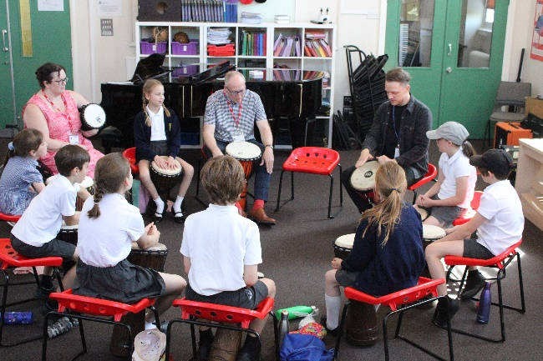

THE OLD BOOT BIKERS – SUMMER BASH!
SUNDAY 6th JULY 11am – 7pm
HORSES MEADOW, DANE END


Visit our village Facebook page LOVE DANE END For all the community to share positive stories about
our wonderful parish, activities, events and to
promote our communities in neighbouring villages.
The link is: LOVE DANE END
https://www.facebook.com/groups/874448604284212/
GREAT MUNDEN RECREATIONAL GARDEN
Chess with Tim
6pm to 8pm on Thursdays
Children and adults, £1 per person per session, to raise funds for the Garden.
One parent will need to stay for the duration.
Nathalie – Movement to Music
Thursday mornings at Little Munden Memorial Hall at 11.15am. This class will carry on until the warmer weather returns and hopefully come back to the Garden for exercises in the fresh air.

Yoga with Josie
Depending on the weather, these may take place at the Garden from May onwards.
Every Saturday 10am to 11am in the Memorial Hall
£10 per class. Call Josie: 07947 653380
Le French Club – Sundays from 12 noon
£1.50 per person, or £1 for concessions.
Back at the Garden, weather permitting.

Dane End Memorial Hall Are Taking Bookings
Landline: 01920 512535
Email: hallbookings1924@yahoo.com
Mobile: 07785663225
Available for hire by the hour or mornings, afternoons and evenings
If you want to arrange a birthday party, start a bridge or table tennis club.....
Give us a call!

DANE END DEFIBRILLATOR & VETS NUMBER
Please be aware there is a Public Access Defibrillator situated in the telephone box in a locked cabinet next to Dane End Stores. The code for the cabinet can be obtained by ringing 999. However there is also Village Emergency Telephone System (VETS) that enables up to 10 "good neighbours" to assist pending the arrival of the emergency services. VETS uses a simple memorable number unique to the village (01920 282999). This system can also be used for any emergency where additional help is required from neighbours, whether Cardiac Arrest or not. VETS volunteers are also aware of the code to access the cabinet if it is required. VETS does not replace 999 calls. Always ring 999 first in an emergency.
MONTHLY COFFEE MORNING
Coffee and cake or
Russells famous sausage rolls for £6!
at the
Christmas Tree Farm from 9 - 12 noon
On Friday 20th June …..
AND
The Monthly PIZZA and Wine/Beer etc.
ON FRIDAY 27th JUNE
Get Together
From 7pm
Eat and drink all day!



