The Mundens with Sacombe
Church and Parish
Newsletter
MAY 2025

Every Tuesday
9.30am Holy Communion (BCP)
and Bible Study Sacombe
Every Wednesday
9.30am Worship & Bible Study Standon
Sunday 4th May (Easter 3)
8.00am Holy Communion Standon
10.30am Morning Worship Lt Munden
Sunday 11th May (Easter 4)
10.30am Holy Communion Standon
Sunday 18th May Easter 5)
8.00am Holy Communion Standon
10.30am Holy Communion Lt Munden
Sunday 25th May (Easter 6)
10.30am Morning Worship Standon
6.00pm Choral Evensong Standon
Sunday 1st June (Sunday after Ascension)
8.00am Holy Communion Standon
10.30am Morning Worship Lt Munden
Rector: Revd John Chitham 01920 739483
The Vicarage, Standon
Sacombe Churchwardens:
Janet Armstrong 07376 249047
Derek Wheeler 01920 438875

Website: www.achurchnearyou.com/benefice/32-240BF
www.facebook.com/unitedbenefice3

LETTER FROM THE RECTOR
Dear Friends
8 May is Victory in Europe Day. It is a day that has particular resonance for me as I have photos of my father on VE Day in Hamburg, celebrating the end of the war. He was in the Army Film and Photographic Unit, and took some stunning photographs of the war. Nonetheless these photos are slightly blurred, despite being taken by one of the professionals in the unit. There are many (looted?) empty champagne bottles around, which may have contributed to the blurring…
Perhaps we are a nation overly used to looking back for our triumphs and celebrations. It is now 80 years since that great day and there are very few participants still alive. We are now living largely from written records, not live memories. So, what does victory look like today? Inevitably it is very different because we do not face the threat we faced in 1939. Or do we? There are signs everywhere of the weathering of the West, of the post WW2 settlement wearing thin and the rise of other powers and influences. I am not competent to write about that (we will all have our opinions) but I can perhaps reflect on the nature of a different victory.
For the Christian some of the elements of VE are those to which we aspire: self-sacrifice, a higher duty and calling, a love for neighbour and (when we were at our best in WW2) a love for neighbour that transcended revenge. These are still values that I trust our churches (and villages) will hold dear. But there is an even greater victory that was completed in defeat: the death of Jesus. There can be no doubt that the cross was, in any human terms, the most abject defeat. Humiliation, abandonment and death are not the stuff of daring WW2 stories. Yet here was defeat but not failure. Ironically in the defeat came the greatest victory of all time. For through death came resurrection, and through resurrection came the defeat of death. It is a victory beyond the dreams of VE day. It is an eternal victory that will never fail. In the celebrations of VE day, I recommend a little reflection on that still greater victory!
John Chitham

COUNTRY MATTERS (9^{h} April)
The old proverb “A peck of dust in March is worth a Kings ransom” has been made to look silly this spring with no rain for weeks and the ground like concrete.
As a consequence there’s very little grass so far, so the first bunch of thirty cattle that went out today (April 9th) will have to be fed some hay until we get this promised rain. However, being out at grass means that they won’t need bedding, saving us on straw.
Only two calves were born in the last month, one to a first-time heifer; she ignored her calf at first and gave us quite a bit of trouble before she took to it.
Chiffchaffs appeared on March 19th and the first Swallow passed through on April 4th. You have to realise that a Swallow like that might well have another seven hundred miles to go.
During the last few days we have seen a number of Brimstone butterflies, a Peacock and a Comma, and yesterday the first moth.
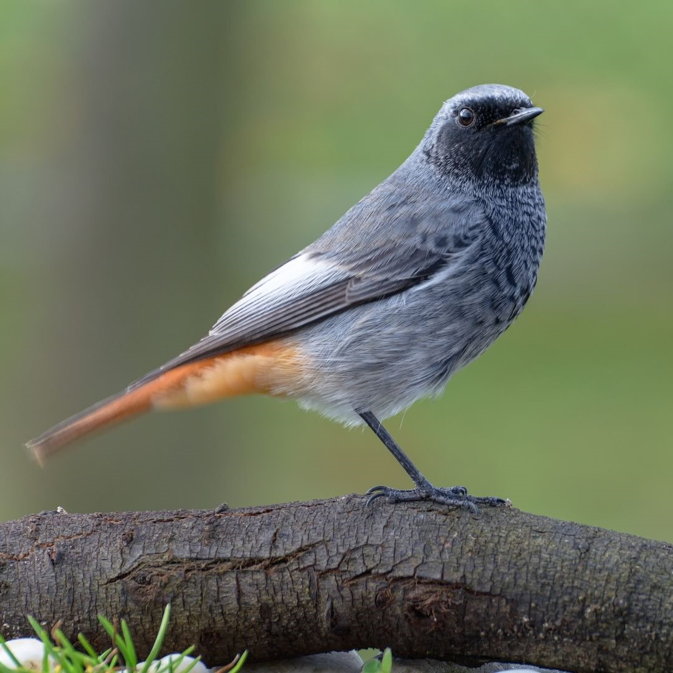
BIRD OF THE MONTH: BLACK REDSTART
The Black Redstart looks rather like a Robin, with black head and breast. Like the Robin, it is in the thrush family. We’ve seen four or five pass through the farm from time to time, never staying for long. They shun woodland, preferring open areas, especially rocky places like quarries. At the end of the second world war quite a few nested among the rubble of bomb sites in London.
We once had a holiday in Switzerland, and from our hotel window we had a good view over a grassy valley surrounded by mountains. All over the area there were log cabins, and every one had a male Redstart on the roof, singing as if it was the owner.
COMMUNITY ALLOTMENT
We need to raise much needed funds to buy a polytunnel and other equipment for the site. We have set up a GO FUND ME PAGE: The Link is: https://youtu.be/RPxf2F9xnvA…. Please give what you can to help us get this fantastic project to the final stage.


Or if you have any old garden tools you no longer require, feel free to drop them off on the allotment. Thank you. The Green Berets
(AKA Allotment Volunteers)

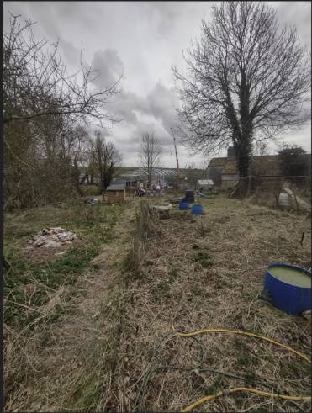
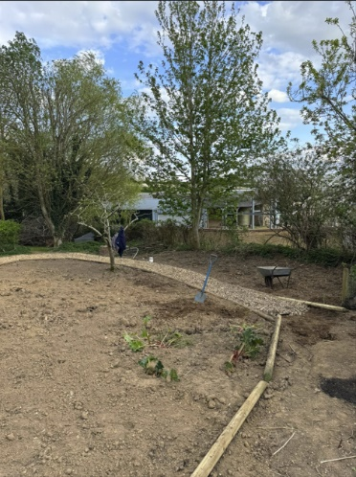

Our lovely community allotment has progressed a long way from looking like an unloved patch of land with a lot of rubbish especially roof tiles and carpet under its soil. To a cleared plot ready for the next stage in its development.
We have had a group of avid volunteers helping with the clearance works and even though it has been very hard, physical work we have all really enjoyed coming together to achieve so much in such a small amount of time, some pictured below. But many others have helped along the way.
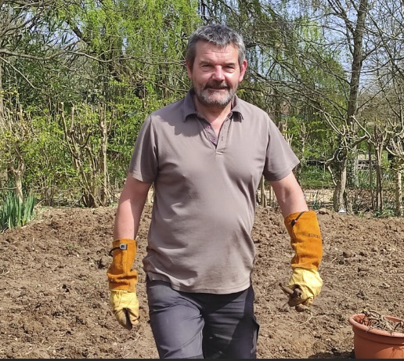
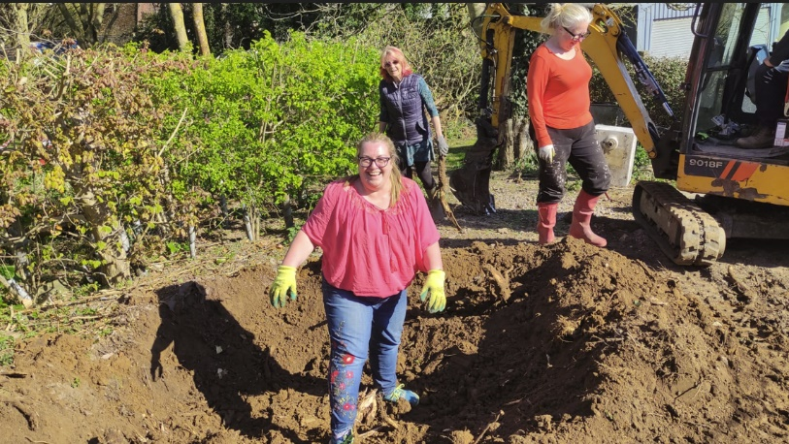

We are hoping to see a lot more residents coming down over the coming weeks and months to join in and grow some fruit and vegetables or just pop down for a chat. Once we near completion of the site we will have an open day for people to come along and find out what exciting plans we have for the site. We have recently planted seed potatoes and will be looking to plant other vegetables over the coming weeks. Please do come down and join in when you can.

LITTLE MUNDEN PARISH COUNCIL
A FULL Council Meeting will be held:
7pm on TUESDAY MAY 20th
In the Memorial Hall, Dane End
Please note: Public attendance will be strictly
limited. If you would like to receive an invitation
please email the clerk:
clerk@littlemundenplc.og.uk

LITTLE MUNDEN PARISH COUNCIL
80th VE DAY COMMEMORATION
8th MAY
AT HORSES’ MEADOW
DANE END
WARE
FROM 6pm
BAR
FISH and CHIPS
MUSIC
AT 9.30pm
LIGHTING OF THE BEACON
COMMEMORATION
Followed by a glass of prosecco
For further information please contact clerk@littlemundenpcs.org.uk
SACOMBE PARISH
Parish AGM to be held on Thursday 15th May at 8pm at St Catherine's Church, Sacombe
All Sacombe parish residents welcome

DANE END DEFIBRILLATOR & VETS NUMBER
Please be aware there is a Public Access Defibrillator situated in the telephone box in a locked cabinet next to Dane End Stores. The code for the cabinet can be obtained by ringing 999. However there is also Village Emergency Telephone System (VETS) that enables up to 10 "good neighbours" to assist pending the arrival of the emergency services. VETS uses a simple memorable number unique to the village (01920 282999). This system can also be used for any emergency where additional help is required from neighbours, whether Cardiac Arrest or not. VETS volunteers are also aware of the code to access the cabinet if it is required. VETS does not replace 999 calls. Always ring 999 first in an emergency.

6th JULY
THE OLD BOOT BIKERS SUMMER BASH
HORSES’ MEADOW

Dane End Memorial Hall Are Taking Bookings
Landline: 01920 512535
Email: hallbookings1924@yahoo.com
Mobile: 07785663225
Available for hire by the hour or mornings, afternoons and evenings
If you want to arrange a birthday party, start a bridge or table tennis club.....
Give us a call!

DAME ENDERS
Our dates for the coming year are:
Thursday 6th May in the Memorial Hall 8pm
Thursday 5th June
Thursday July 10th BBQ
Thursday September 4th Our planning meeting
Thursday October 2nd
Thursday November 6th
Thursday December 4th Christmas meal in the hall, subject to change depending on the Parish Council Panto.

A big thank you to all those who attended the coffee morning at All Saints church last month.
Also thank you to Judy Rowley who kindly supplied all the daffodils for the posies made for Mothering Sunday.
We had a very successful morning and managed to raise £554 in donations towards the repair of the church roof.
Please look out for the next fundraiser to help pay for the “very old “ church roof.
Many thanks Deborah Ovens

Visit our village Facebook page LOVE DANE END For all the community to share positive stories about
our wonderful parish, activities, events and to
promote our communities in neighbouring villages.
The link is: LOVE DANE END
https://www.facebook.com/groups/874448604284212/
GREAT MUNDEN RECREATIONAL GARDEN
Chess with Tim - returning Thursday 29th May
Please come along from 6pm to 8pm on Thursdays and have fun playing against other local chess enthusiasts, children and adults, while enjoying the sunset and listening to the peaceful sound of birds chirping and leaves rustling in the breeze.


Tim is a seasoned chess player who volunteers throughout the winter at the Bishops Stortford Chess Club and has kindly offered to run an outdoors club at the Garden.

£1 per person per session, to raise funds for the Garden. One parent will need to stay for the duration.

Postcode: SG11 1HH
What3words: Boardroom, tagging, civic

Flea Market SUNDAY 25th MAY
9am to 12.30pm Free Entry for Buyers
Sellers £2 entrance Arrive from 8.15am
The sun is back and the vintage sale is returning to the Garden. Perfect timing for spring cleaning to declutter and sell your unwanted goods.
Fancy a nice stroll in the sun picking out some rare antique or vintage pieces?
Come along, we even have tea and coffee for a donation.

Friday Alfresco – Friday 9th May – from 7pm

The first Friday Alfresco of the year will be held exceptionally on Friday 9th May.
We look forward to seeing everyone to catch up after the long dreary dark winter months.
You know the drill, pop along with your snacks and drinks, and get to meet local people in your area, catch up with old friends and make new ones.

Annual General Meeting Sunday 18th May at 4.30pm
Come and find out more about the Garden, meet the Trustees, ask questions or offer your help.

Nathalie – Movement to Music
We are pleased to let you know that Nathalie is now running classes on Thursday mornings at Little Munden Memorial Hall at 11.15am. This class will carry on until the warmer weather returns and hopefully come back to the Garden for exercises in the fresh air. Car parking available at the rear of the hall.


Yoga with Josie
Depending on the weather, these may take place at the Garden from May onwards.
Every Saturday 10am to 11am in the Memorial Hall
£10 per class. Call Josie: 07947 653380

Le French Club
If you want to brush up on your French before your next holiday, join the French club and meet French speakers locally, learn new vocabulary and improve on your grammar. £1.50 per person, or £1 for concessions. Back at the Garden, weather permitting.


Little Munden C of E (VC) Primary School
Building Good Foundations.
Matthew 7, verse 24
Church Lane, Dane End, SG12 0NR
Tel: 01920 438271 option 3
Email: admin@littlemunden.herts.sch.uk
www.littlemunden.herts.sch.uk

April 2025
School Choir
The musicians at Little Munden School have been very busy over the last few weeks! On Good Friday, several members of the choir joined the adult church choir to sing during the Good Friday service at All Saints Church.
They also sang a piece on their own, and were involved in the dramatic retelling of the Easter story.

All the children who do either choir with Miss Franks or music lessons with Mrs Hembrough, went on an outing to St Mary’s Church, Standon to a lunchtime concert. Mrs Hembrough was playing her violin and we all really enjoyed listening to her, especially at the end when she played Beauty and the Beast! In a couple of weeks' time, the choir is going to St Edmund's College to take part in a singing morning with their head of music,
Mr O'Brien. What a lot of fun we're having!



MONTHLY COFFEE MORNING
Coffee and cake or
Russells famous sausage rolls for £6!
at the
Christmas Tree Farm from 9 - 12 noon
On Friday 16th May …..
AND
The Monthly PIZZA and Wine
Get Together
From 7pm
Eat and drink all day!

LITTLE MUNDEN PARISH COUNCIL
Litter Pick – Adopt A Street
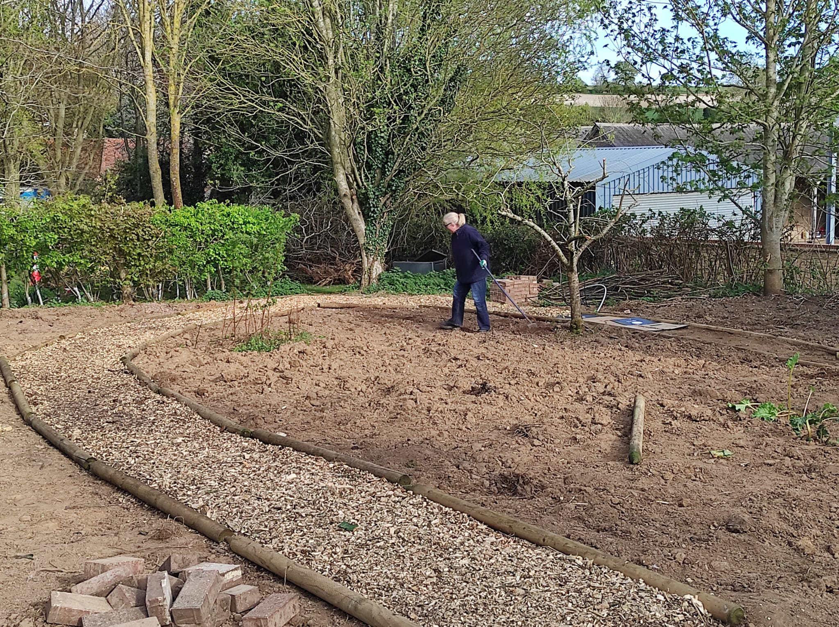
As we explained previously the Council have cut our budget for litter collection. We are looking for volunteers to adopt their street and collect any rubbish. We can supply a litter picker and high vis jacket to any volunteers. If you are interested in keeping your street tidy, please email our clerk at clerk@littlemundenpc.org.uk and we will be in touch. If we all do a little, we can keep our village looking lovely.

LITTLE MUNDEN PARISH COUNCIL
DATES FOR YOUR DIARY!

8th May - 80th VE Day Commemoration
Horses Meadow
5th July - The Old Boot Bikers
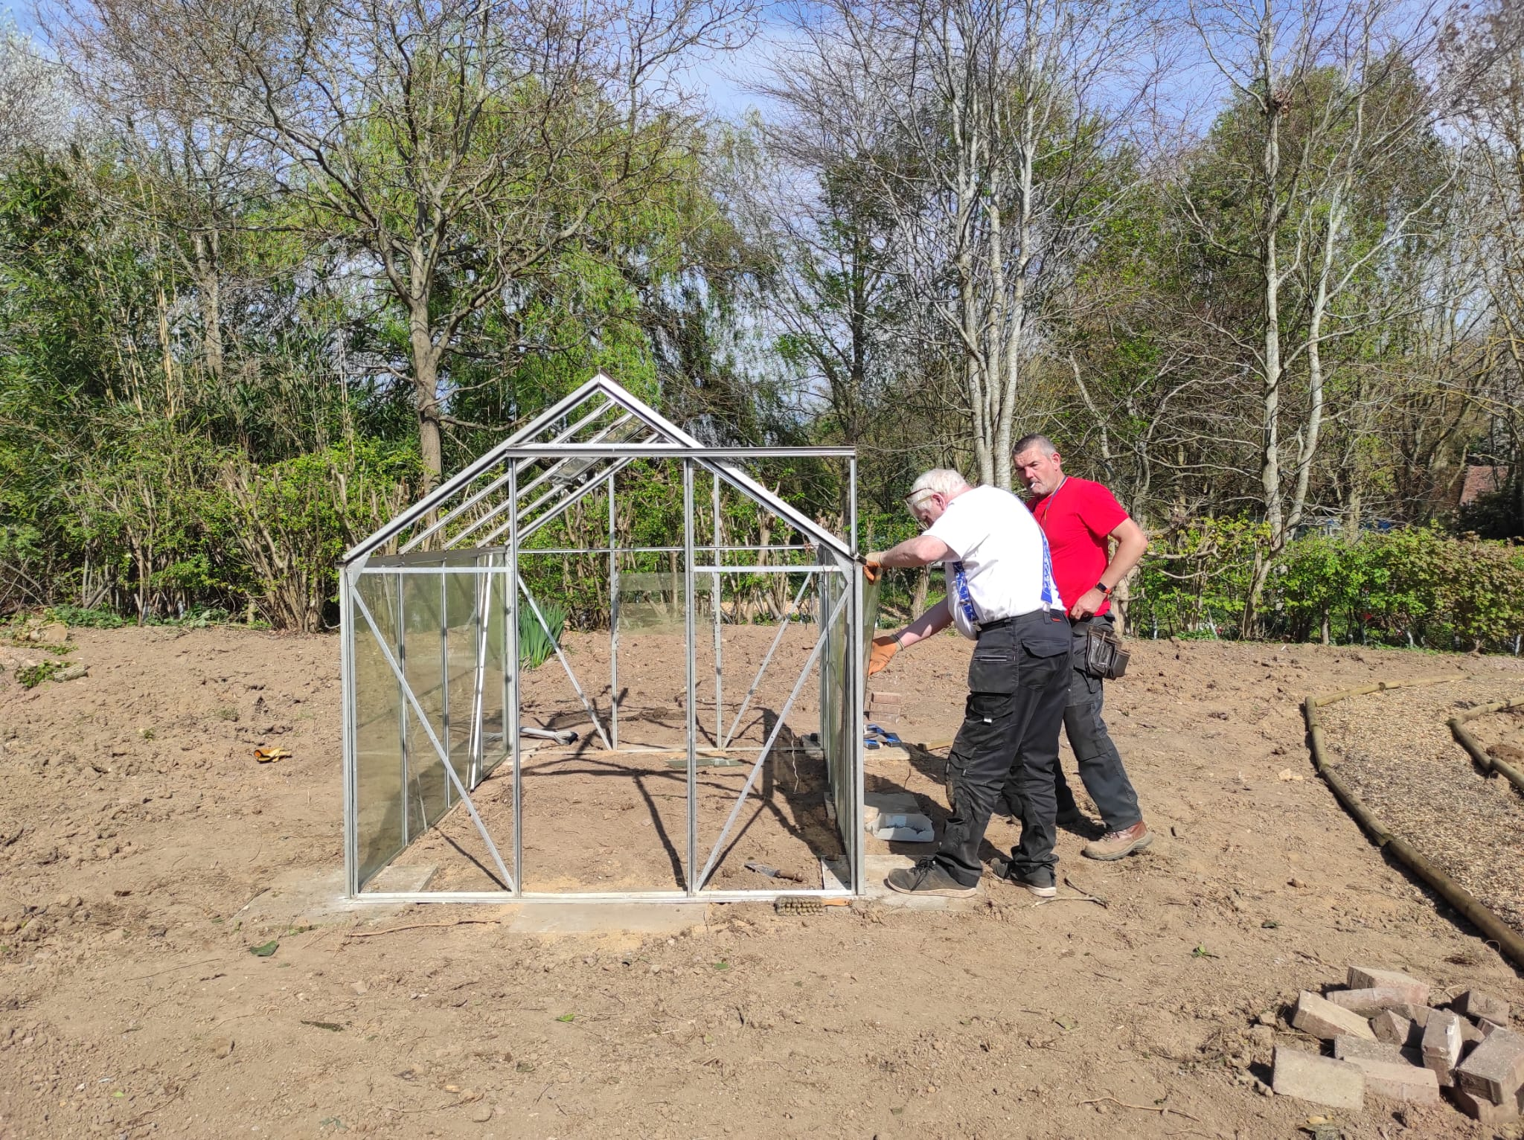
Custom bikes and vintage cars
Horses Meadow
6th September - LMPC Village Fair
Throughout the summer there will be outdoor cinema events on Horses Meadow.
Dates to be announced.
Autumn - Halloween Party
Christmas - Panto Again!
Dates to be announced.

MORE PHOTOS OF THE
‘GREEN BERETS’
IN ACTION!

